Ermil D. Shifferly
October 22, 1921 – August 11, 2011

r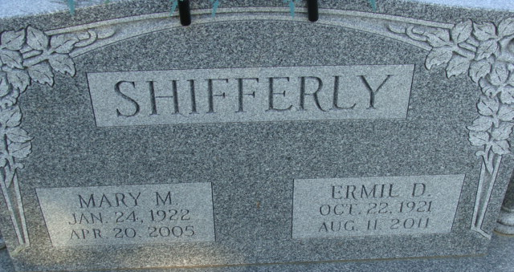
Photo by Deb Curry

Ermil D. Shifferly, 89 years old and a longtime resident of Monroe, Indiana passed away on Thursday, August 11, 2011 in Adams Memorial Hospital. He had resided at Woodcrest Nursing Center for the past two years.
He was born on Saturday, October 22, 1921 in Adams County, Indiana, the son of the late Otis E. Shifferly and the late Iona M. (Hart) Shifferly. He married the late Mary M. Burger on April 3, 1943 in Adams County, Indiana and she passed away on April 20, 2005.
Ermil was a WW II veteran of the United States Army serving in France and Central Europe. He was a member of the Decatur Church of God, and he retired in 1987 from CTS in Berne with twenty-two years of service.
Surviving is his son, Duane D. (Jackie) Shifferly of Monroe, Indiana; daughter, Arlene K. (Allen) Steffen of Bluffton, Indiana; sister, Mildred Wagoner of Columbia City, Indiana, four grandchildren and fourteen great-grandchildren. Preceding Ermil in death were a brother, Eldred V. Shifferly and a sister, Doris McDermott.
Funeral services will be held at 11:00 a.m. Tuesday, August 16, 2011 in the Decatur Church of God with Dr. Robert Brink officiating. Interment will follow in the Decatur Cemetery. Friends will be received from 4 to 8 p.m., Monday, August 15 in the Zwick & Jahn Funeral Home, Decatur. There will also be calling on Tuesday from 8:30 a.m. to 9:30 a.m. in the Woodcrest Chapel and from 10:00 a.m. until the time of service on Tuesday at the church.
Preferred memorials are to Decatur Church of God.

Zwick & Jahn Funeral Home, Adams County, Indiana
August 12, 2011

