Eldred Verlin Shifferly
August 18, 1913 – October 17, 1935

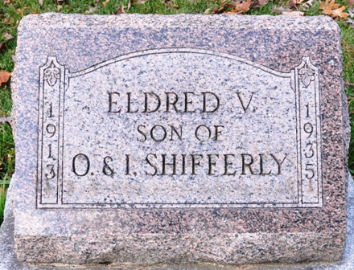
Photo by Deb Curry

Eldred Abelin Shifferly
in the Indiana, U.S., Death Certificates, 1899-2017
Name Eldred Verlin Shifferly
Gender Male
Race White
Marital Status Single
Age 22
Birth Date 18 Aug 1913
Birth Place Indiana
Death Date 17 Oct 1935
Death Place Adams, Indiana, USA
Death Registration Date 1935
Father Otis Shifferly
Mother Jena?? Hart
Informant Mrs. O. E. Shifferly; Decatur, Indiana
Burial October 20, 1935; Decatur Cemetery

