Donald G. Shifferly
June 7, 1941 – July 12, 2002
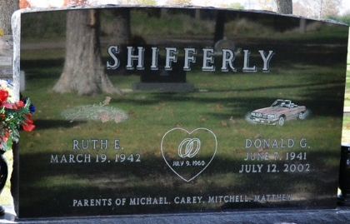

Photo by Deb Curry

Donald G. Shifferly, 61, of Decatur, founder and president of Shifferly Dodge Inc., died Friday, July 12, 2002, at St. Joseph Hospital, Fort Wayne. The Adams County native was a member of St. Mark's United Methodist Church, Masonic Lodge No. 571, Elks No. 993 and Sons of the American Legion.
Surviving is his wife, Ruth E.; a daughter, Carey Shifferly of Decatur; sons Michael, Matthew and Mitch, all of Decatur; and four grandchildren.
Services are 11 a.m. Monday at St. Mark's United Methodist Church, Decatur, with calling one hour before services, and from 6 to 8 p.m. Saturday and 11 a.m. to 1 p.m. and 3 to 6 p.m. Sunday at Zwick & Jahn Funeral Home, Decatur. Burial will be at Decatur Cemetery.
Memorials are to the church or to the donor's choice.
Information provided by Zwick & Jahn Funeral Home, Decatur, 1-260-724-9164.

News-Sentinel, The (Allen County, Indiana)
Saturday, July 13, 2002

**
Indiana, U.S., Death Certificates, 1899-2017
Name Donald G Shifferly
Gender Male; Race White
Marital Status Married
Age 61
Birth Date 7 Jun 1941
Birth Place Adams County, Indiana
Death Date 12 Jul 2002
Death Place Fort Wayne, Allen, Indiana, USA
Father Ivan Dale Shifferly
Mother Ruth Miller
Spouse Ruth Wheat
Informant Ruth Shifferly; wife; Decatur, Indiana
Burial July 15, 2002; Decatur Cemetery; Decatur, Indiana

