Thomas J. Shields
June 7, 1827 – May 7, 1893

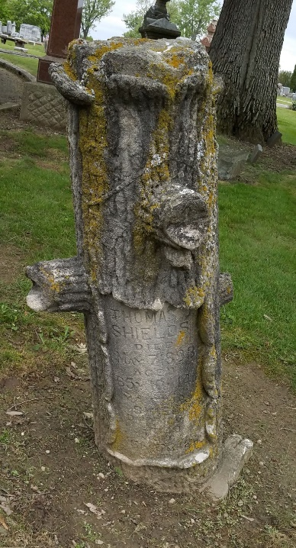
Photo by Deb Curry

Thomas J. Shields was born in Fremont (then Sandusky City), Ohio, June 7, 1827, and died in Decatur, May 7th, 1893, aged 65 years and 11 months.
He came to Adams County in 1876, and was engaged in the saw mill business for about three years. In 1879, he was appointed by the Commissioners Janitor of the County Court House; a position he competently and satisfactorily filled for fourteen years. Besides being a practical engineer, he was a great lover of horses, and always was in possession of one or more of the equine family. Among the many he has owned, "Ralph Jones," the handsome roan stallion, was the most noted. To him can be credited the keeping up of the speed department of our Agricultural Society during its most animated career.
Previous to moving to this county, he resided in Monroeville, Allen County. He was twice married; his first wife died during the latter sixties. He was a member of Monroeville Lodge, F. & A. M., and was buried by them, assisted by Willshire and Decatur Lodges.
His death was the result of brain trouble, which he complained of to the writer during his pain-suffering, many months previous to his death. He had many friends. To know him intimately was to know a kind, generous and true friend. His remains were taken to "Maple Grove Cemetery," for burial, followed by a large number of friends and relatives, who will long remember and mourn the loss of "Tom" Shields.

Decatur Democrat; Adams County, Indiana
May 12, 1893
**

Thomas J. Sheilds from tree Boyd Family Tree
Birth 24 Mar 1833
Marriage 23 Sep 1869 Miami, Indiana, USA
Death 7 May 1893 Decatur, Adams, Indiana, USA
Record information.
Spouse Martha M (ROSS) Shields (1847-1898)

