Martha M. (Ross) Shields
June 3, 1847 – November 15, 1898

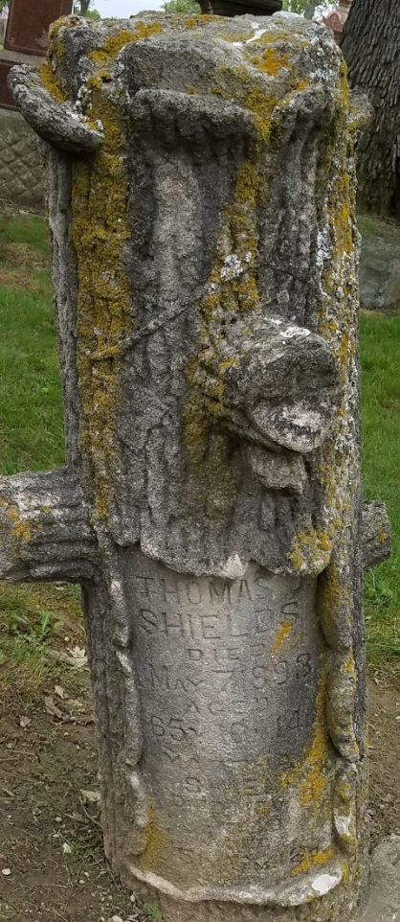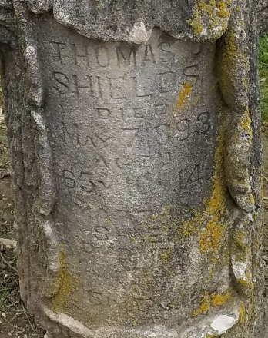
Photo by Deb Curry

Mrs. Thomas Shields died at her home on First Street, Tuesday morning at 8:30 o'clock after a week of terrible suffering. She was stricken with paralysis on the Wednesday preceding and her condition was unknown to her friends and neighbors until Friday. She was utterly unconscious most of the time; still those in attendance could tell that her sufferings were beyond endurance.
A brother of hers, Mr. Samuel Ross, of Bowling Green, Ohio, was notified of her illness and arrived Friday evening, during which time he and other friends did everything possible for her relief, but without avail.
Martha Ross Shields was born in North Umberland County, Pennsylvania, June 3, 1847, and died November 15, 1898, aged fifty-one years, five months and twelve days. When still very young, her parents moved with her to Seneca County, Ohio. Afterwards they moved to Sandusky County, where she was raised to womanhood and where in 1869, she was married to Mr. Thomas Shields, who preceded her to the better land.
In 1872, Mr. and Mrs. Shields moved to this county, where they have since resided. Mrs. Shields has always been a leading Christian worker and a kind and loving neighbor, and her hosts of friends here will feel her loss most keenly.
Three brothers and one sister are left to mourn the loss of one they loved very dearly.
The funeral services will be held from the Methodist church this afternoon at two o'clock, Rev. Daniel officiating, and the body will be laid to rest in Maplewood Cemetery.
Samuel Ross, wife and son, Allen, of Bowling Green, Ohio, Enoch Ross and son Charles, of Fort Wayne, John Ross of Defiance, and Mrs. Ellen Hilt of Bowling Green, Ohio, are here to attend the services.

Decatur Democrat; Adams County, Indiana
Thursday, November 17, 1898

**
Martha M Ross from tree Hess-Ross Family DNA Tree
Birth 1847 Northumberland, Pennsylvania, USA
Residence 1860 Plain, Wood, Ohio, USA
Marriage 23 Sep 1869 Fort Wayne, Allen, Indiana, USA
Death 15 Nov 1898 Decatur, Indiana, USA
Father John L Ross (1811-1894)
Mother Anna Barrett (Ross) (1811-1885)
Spouse Thomas J Shields (Born 1840)

