Raymond L. Shepherd
June 5, 1919 – June 7, 1984

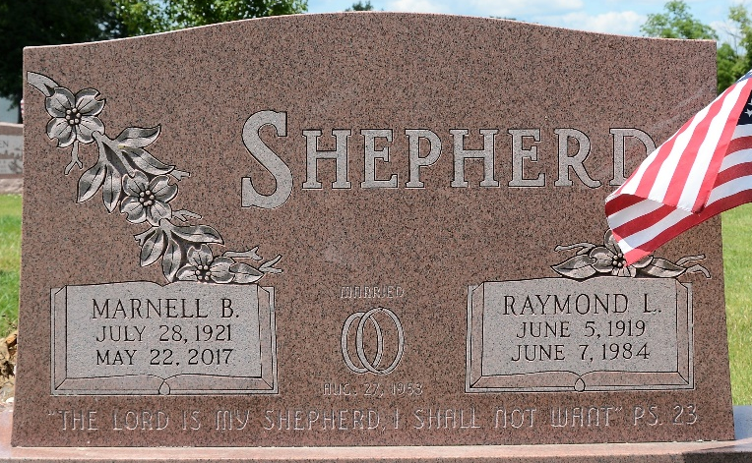
Photo by Deb Curry

Raymond L. Shepherd
in the Indiana, U.S., Death Certificates, 1899-2017
Name Raymond L. Shepherd
Gender Male
Race White
Marital Status Married
Age 65
Birth Date 5 Jun 1919
Birth Place Indiana
Death Date 7 Jun 1984
Death Place Fort Wayne, Allen, Indiana, USA
Death Registration Date 1984
Father Raymond A. Shepherd
Mother Fanny Smith
Spouse Marnell Burns
Informant Marnell B. Shepherd; wife; Decatur, Indiana
Burial June 9, 1984; Decatur Cemetery; Decatur, Indiana

