Marnell B. (Burns) Shepherd
July 28, 1921 – May 22, 2017

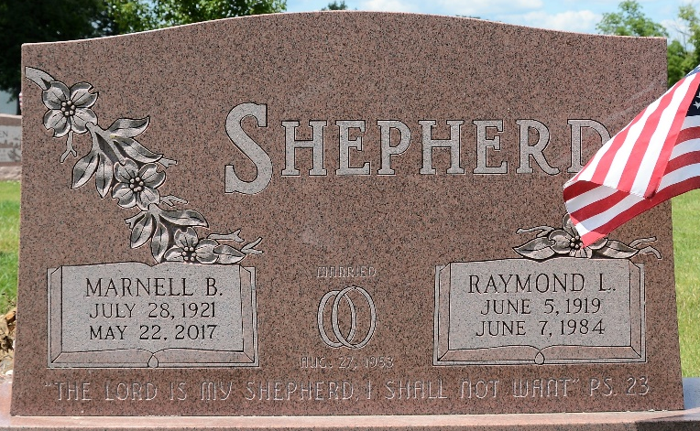
Photo by Deb Curry

Marnell B. Shepherd
in the U.S., Cemetery and Funeral Home Collection, 1847-Current
Name Marnell B. Shepherd
[Marnell B. Burns]
Gender Female
Death Age 95
Birth Date 28 Jul 1921
Birth Place Lincoln County Arkansas
Residence Place Akron
Death Date 22 May 2017
Burial Date 31 May 2017
Burial Place Decatur, Indiana
Obituary Date 18 Oct 2019
Obituary Place Fairlawn, Ohio, USA
Father Andy Burns
**
Marnell Burns from Ronnie Sullivan Family Tree
Spouse Raymond Leroy Shepherd
Father Andy S Burns
Mother Flora Matthews
Birth 28 Jul 1921 Lincoln, Arkansas, USA
Death 22 May 2017 Ohio, USA
Residence 1935 Lincoln, Arkansas, USA

