Trent I. Shelton
August 20, 1968 – May 23, 1985

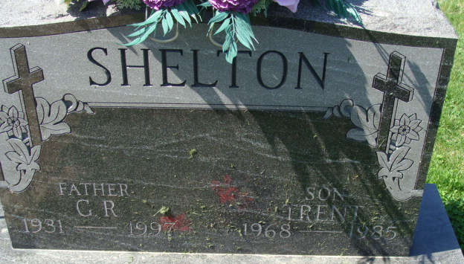
Photo by Alicia Kneuss

Private committal services were held this morning at Decatur Cemetery for Trent I. Shelton, killed last week in a traffic accident.
Winteregg-Linn & Haggard Funeral Home was in charge of arrangements.
Decatur Daily Democrat; Adams County, Indiana
May 28, 1985
**
Indiana, U.S., Death Certificates, 1899-2011
Name: Trent I Shelton
Gender: Male
Race: White
Age: 16
Marital status: Never Married (Single)
Birth Date: 20 Aug 1968
Birth Place: Indiana
Death Date: 23 May 1985
Death Place: 3 1/2 MI SE Decatur, Adams, Indiana, USA
Father: Gerald R Shelton
Mother: Esther Cook
Informant: Esther Shelton; mother; Decatur, Indiana
Burial: May 28, 1985; Decatur Cemetery; Decatur, Indiana

