Norma J. (Fuchs) Shelton
May 2, 1928 -

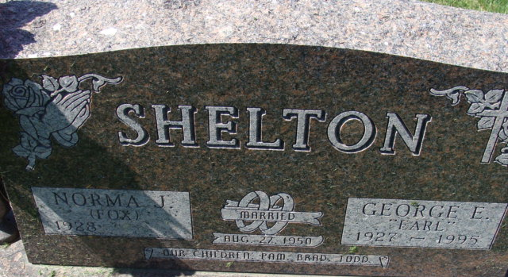
Photo by Alicia Kneuss

Fuchs
in the Indiana, U.S., Birth Certificates, 1907-1944
Name Fuchs
Gender Female
Birth Date 2 May 1928
Birth Place French, Adams, Indiana, USA
Father Jesse Fuchs; age 22
Mother Dora Hirschy; age 19; 1st child
Certificate Number 20402
Roll number 40474_357832
Volume Range 41 - 45

