Gerald R. Shelton
September 5, 1931 – April 12, 1997

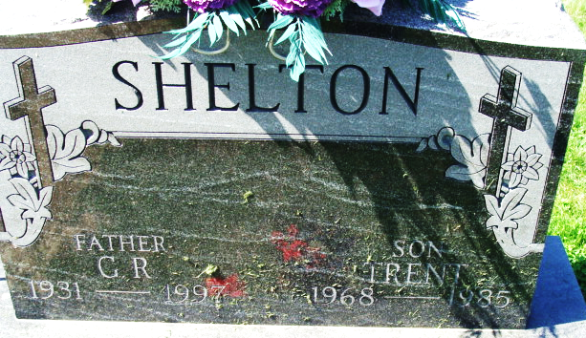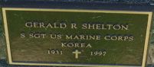
Photo by Alicia Kneuss

Gerald R. Shelton
in the Indiana, U.S., Death Certificates, 1899-2017
Name Gerald R. Shelton
Gender Male
Race White
Marital Status Divorced
Age 65
Birth Date 5 Sep 1931
Birth Place Wilmington, Ohio
Death Date 12 Apr 1997
Death Place Decatur, Adams, Indiana, USA
Death Registration Date 1997
Father Willie G. Shelton
Mother Lilly A. Tolle
Informant Cassandra Wallace; daughter; Fort Wayne, Indiana
Burial April 16, 1997; Decatur Cemetery; Decatur, Indiana

