George E. Shelton
April 16, 1927 – August 16, 1995

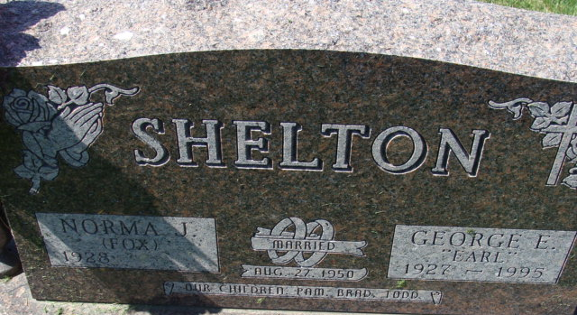
Photo by Alicia Kneuss

George E. Shelton, 68, of Decatur died yesterday at home. The Clinton County, Ohio, native was a retiree of the Great Atlantic and Pacific Tea Store in Decatur and Decatur Industries, and currently a driver for Johnson Auto Sales.
Surviving is his wife, Norma; a daughter, Pam Thomas of Decatur; sons, Brad and Todd, both of Decatur; sisters, Merle Drake and Ruth Lee, both of Decatur; brothers, Gerald of Decatur, Glenn of Angola, Willard of Las Vegas and Jim; and seven grandchildren.
Services are 10 a.m. Saturday in Haggard & Armes Funeral Home, Decatur, where calling is 2 to 5 and 7 to 9 p.m. tomorrow, with a Moose memorial service at 8:45 p.m. Burial will be in Decatur Cemetery.
Preferred memorials are gifts to Zion United Church of Christ, Decatur.

News-Sentinel, Allen County, Indiana
Thursday, August 17, 1995

**
Indiana, U.S., Death Certificates, 1899-2017
Name George E Shelton
Gender Male
Race White
Marital Status Married
Age 68
Birth Date 16 Apr 1927
Birth Place Clinton County, Ohio
Death Date 16 Aug 1995
Death Place Decatur, Adams, Indiana, USA
Death Registration Date 1995
Father William G Shelton
Mother Lillie Tolle
Spouse Norma J Fox
Informant Norma J. Fox Shelton; wife; Decatur, Indiana
Burial August 19, 1995; Decatur Cemetery; Decatur, Indiana

