Esther I. (Cook) Shelton
January 24, 1938 – August 5, 2000

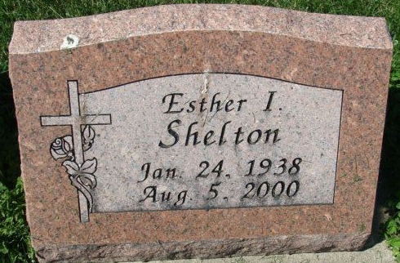
Photo by Alicia Kneuss

Esther I. Shelton, 62, of Decatur, a secretary, died Saturday, Aug. 5, 2000, at home. The Decatur native worked for Zion United Church of Christ for seven years, was also a homemaker and a member of Decatur Church of God.
Surviving is a daughter, Cassandra Wallace of Fort Wayne; her parents, Lester and Margaret Cook of Decatur; a brother, Gerald J. Cook of Decatur; a sister, Ethel L. Bienz of Decatur; and two grandchildren. She was preceded in death by a son, Trent I.
Services are 11 a.m. Wednesday at Haggard & Sefton Funeral Home, Decatur, with calling from 2 to 4 and 6 to 8 p.m. today. Burial will be at Decatur Cemetery.
Memorials are to Youth for Christ or the SADD Chapter at Belmont High School.

News-Sentinel, Allen County, Indiana
August 8, 2000

**
Indiana, U.S., Death Certificates, 1899-2017
Name Esther I. Shelton
[Esther I. Cook]
Gender Female
Race White
Marital Status Divorced
Age 62
Birth Date 24 Jan 1938
Birth Place Decatur, Indiana
Death Date 5 Aug 2000
Death Place Decatur, Adams, Indiana, USA
Death Registration Date 2000
Father Lester R. Cook
Mother Margaret A. Burgo
Informant Cassandra Wallace; daughter; Fort Wayne, Indiana
Burial August 9, 2000; Decatur Cemetery; Decatur, Indiana

