Bradley Kent Shelton
January 19, 1953 – August 15, 2023

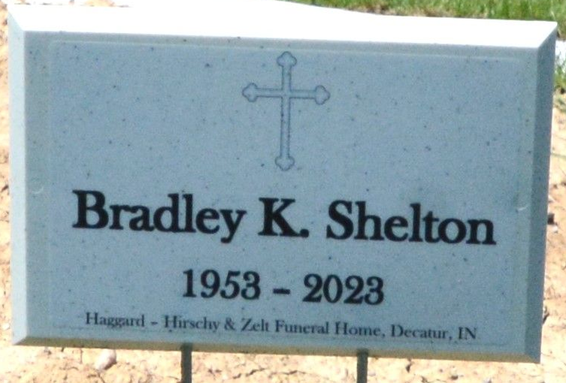
Photo of Deb Curry

Bradley Kent Shelton, 70, of Decatur, IN, passed away on Tuesday, August 15, 2023, at Dupont Hospital. Bradley was born on January 19, 1953, in Decatur, to the late George and Norma (Fox) Shelton.
Bradley retired as a steel worker for Alro Steel.
He is survived by his mother, Norma Shelton of Decatur; a son, Kreigh Shelton of Marshal, MI; 2 daughters, Chyenne (Zach) Wilder and Brittany (Rich) Foreman both of Monroe; a brother Todd Shelton of Decatur; 7 grandchildren, Elijah, Isaiah, Daniel Wilder; Claira, Dexter, Layona and Adelaide Foreman. He is preceded in death by a sister Pam Thomas.
Visitation will be on Sunday, August 20, 2023, from Noon-4:00 p.m. at Haggard-Hirschy & Zelt Funeral Home. A Funeral Service will be held at 10:00 a.m. on Monday, August 21, 2023, also at the funeral home with calling prior from 9:00-10:00 a.m. Pastor Kevin Stirratt will be officiating. Burial will follow in Decatur Cemetery.
Preferred memorials are to Adams County Cancer Coalition.

Haggard & Sefton Funeral Home, Adams County, Indiana
August 16, 2023

