Kenneth B. Shell
May 31, 1920 – November 22, 1999

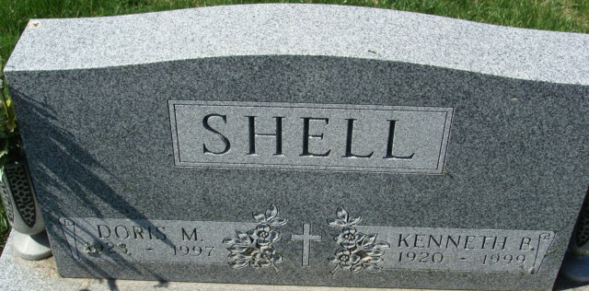
Photo by Barbara Baker Anderson

Kenneth B. Shell
in the Indiana, U.S., Death Certificates, 1899-2017
Name Kenneth B. Shell
Gender Male
Race White
Marital Status Widowed
Age 79
Birth Date 31 May 1920
Birth Place Bobo Indiana
Death Date 22 Nov 1999
Death Place Decatur, Adams, Indiana, USA
Death Registration Date 1999
Father Benjamin F. Shell
Mother Lucy Brothers
Informant Zane R. Zwick; attorney; Decatur, Indiana
Burial November 27, 1999; Decatur Cemetery; Decatur, Indiana

