Doris M. (Beerbower) Shell
September 24, 1923 – September 8, 1997

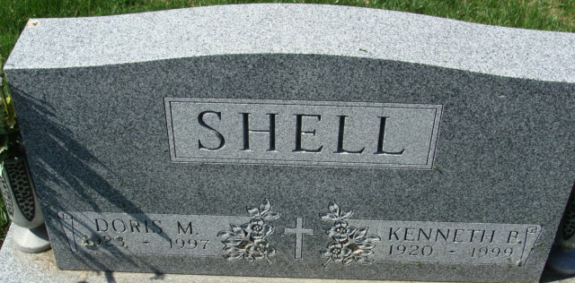
Photo by Barbara Baker Anderson

Doris M. Shell
in the Indiana, U.S., Death Certificates, 1899-2017
Name Doris M. Shell
[Doris M. Beerbower]
Gender Female
Race White
Marital Status Married
Age 73
Birth Date 24 Sep 1923
Birth Place Wells County, Indiana
Death Date 8 Sep 1997
Death Place Decatur, Adams, Indiana, USA
Death Registration Date 1997
Father Theodore Beerbower
Mother Delia Stinson
Spouse Kenneth B. Shell
Informant Kenneth B. Shell; husband; Decatur, Indiana
Burial September 11, 1997; Decatur Cemetery; Decatur, Indiana

