William Eugene Sheets
December 27, 1925 – November 15, 1944

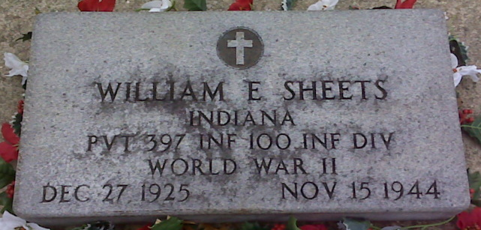
Photo by Lee Sheets

PFC. WILLIAM SHEETS KILLED IN ACTION IN FRANCE NOV. 15

Pfc. William E. Sheets, 19-year-old son of Mr. and Mrs. Don M. Sheets, 919 Winchester Street, was killed in action in France on November 15, the parents were advised by the War Department yesterday.
A week ago today the parents received a message from the war department informing them that their son was missing in action. Their hopes of his survival were shattered with the death message received Sunday.
The Decatur soldier was in France about one month, going overseas last October. He entered the army last March and took training at Camp Fannin, Tex., and Fort Bragg, N. C. Prior to entering the armed forces he was employed at the Schafer Wholesale Company in this city. He attended the Monroeville High School.
A brother, T/5 Robert Sheets, is with the United States Army in France.
Surviving besides the parents and the brother in France, are Mrs. Kathryn Warres, a sister; Richard, Buddie, Betty, Elizabeth and Glenn, at home.

Decatur Daily Democrat, Adams County, Indiana
December 18, 1944

**
BODIES OF FOUR COUNTY WAR DEAD ARRIVE IN U.S.
Remains of Lt. Wayne M. Matchett Arrive at New York

The bodies of four more Adams County World War II dead have arrived in New York from overseas cemeteries for permanent burial in this country. The four are: First Lt. Wayne Myron Matchett, Sec. Lt. Beulah I Barkley, Pvt. William E. Sheets and Cpl. Shelby M. Faulkner.
<snip>
The U. S. Army transport Robert F. Burns also brought the bodies of Pvt. Sheets from the U. S. Military Cemetery at Epinal, France and that of Cpl. Faulkner from Henry Chapelle, Belgium. Lt. Beulah I. Barkley was transported from France.
Killed in Action
Pfc. Sheets was killed in action in France on November 15, 1944. He had been in France about a month before his death, going overseas the previous October. He entered service with the army in March, 1944, and took basic training at Camp Farnin, Tex., and Fort Bragg, N. C. He attended the Monroeville High School and before entering service was employed at the Schafer Wholesale Company. A brother, T-5 Robert Sheets, also served in France.
Survivors include the parents, four brothers; Robert at home, T-5 Glenn, stationed in Nuernberg, Germany; Richard and Buddy at home; three sisters, Mrs. R. C. Warren and Betty of Lake Park, Ga., and Elizabeth at home.
<snip>

Adams County Historical Museum, Adams County, Indiana
December 1947 – April 1948 Scrapbook, image 45
Handwritten date: Wednesday, March 31, 1948

**
Indiana, U.S., Birth Certificates, 1907-1944
Name William Eugene Sheets
Gender Male
Birth Date 27 Dec 1925
Birth Place Decatur, Adams, Indiana, USA
Father Don M Sheets
Mother Ethel C Wynn, 4 of 4 children living
Certificate Number 61121
Roll number 40474_357747
Volume Range 121 - 125

