Vera Louise (Cottrell) Sheets
March 23, 1930 – June 29, 2006

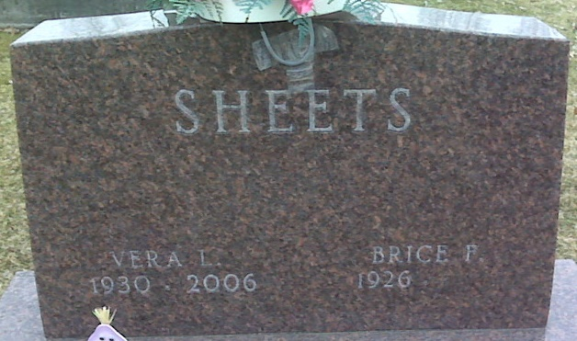
Photo by Lee Sheets

Vera L. Sheets, 76 years old of Decatur, Indiana, passed away at 6:10 p.m. on Thursday, June 29, 2006 in the Adams Memorial Hospital located in Decatur, Indiana.
Vera was born on March 23, 1930 in Decatur, Indiana, the daughter of the late Samuel Cottrell and the late Nellie (Springer) Cottrell. She married Brice F. Sheets on June 20, 1948 in rural Decatur, Indiana and he survives. Vera was a former member of the Mt. Pleasant United Methodist Church. Vera was a nurse's aide for over 25 years at what is now Adams Memorial Hospital.
Surviving are her husband, Brice F. Sheets of Decatur, Indiana, son, Jeff L. Sheets of Decatur, Indiana, son, James F. (Susan) Sheets of Geneva, Indiana, son, Brice A. Sheets of Decatur, Indiana, daughter, Carol (Gary) Frauhiger of Ft. Wayne, Indiana, brother, Don Cottrell of Pittsburgh, Pennsylvania, seven grandchildren, and seven greatgrandchildren. Vera was preceded in death by one great granddaughter, Gabrielle Frauhiger; one daughter, Linda F. Sheets; two sisters, Irene Robison and Ida Mae Clark; and two brothers, Frank and Earl Cottrell.
Funeral services will be held at 1:00 p.m. Monday, July 3, 2006 in the Zwick & Jahn Funeral Home with the Rev. Jeff Taylor officiating. Interment will follow in the Decatur Cemetery. Friends will be received from 12:00 Noon - 4:00 p.m. Sunday, July 2, 2006 in the Zwick & Jahn Funeral Home, Decatur, Indiana; and one hour prior to the service on Monday at the funeral home.
Preferred memorials are to the Vera Sheets Fund.

Zwick & Jahn Funeral Home, Adams County, Indiana
June 30, 2006

