Stephen F. Sheets
June 2, 1945 – December 22, 2020

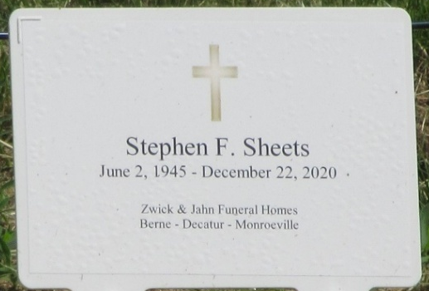
Photo by PLS

Stephen F. Sheets, 75, of Columbia City and former resident of Decatur passed away Tuesday, December 22, 2020, at Lutheran Hospital in Fort Wayne. He was born on June 2, 1945 in Decatur, Indiana to the late Harry Sheets and the late Leona (Zwick) Sheets.
Steve was united in marriage to Kathy Christman on July 17, 1966 at the Salem United Methodist Church of rural Decatur and she survives.
Steve served his country in the United States Army National Guard for six years and was honorably discharged following his term of service.
Steve was a member of the St. Peter Lutheran Church – Fuelling. Steve retired from BF Goodrich in Woodburn following 39 years of employment.
Being outdoors in any type of environment was a joy for Steve. He and Kathy moved to the lake following his retirement which enabled him to continue to fish, hunt, and enjoy nature. When inside, his favorite activity was billiards and he was a member of a club in Ft. Wayne for many years.
Steve is survived by his wife of 54 years, Kathy Sheets of Columbia City, Indiana; daughter, Jodi Sheets of Kansas City, Missouri; son, Kevin (Mary) Sheets of White Bear Lake, Minnesota; daughter, Jana (Luther) Ledic DDS of Milwaukee, Wisconsin; two brothers, James (Beverly) Sheets of Indianapolis, Indiana and David (Ginny) Sheets of Fort. Wayne, Indiana; and six grandchildren, Austin Sheets, Lillian Sheets, Levi Ledic, Elizabeth Ledic, Audrey Ledic, and Lilah Ledic.
A funeral service will be held at 2:00 p.m. Monday, December 28, 2020, at the Zion Lutheran Church, Decatur with Pastor Leonard Tanksley officiating. Burial will follow at Decatur Cemetery. Friends and family will be received from 4-7 p.m. Sunday at the Zwick & Jahn Funeral Home, Decatur and from 1:00 – 1:45 p.m. Monday at the church. Masks will be required.
In lieu of flowers, Steve’s family would ask that memorials be directed to the Loon Lake Association where he was supportive of their efforts to keep the lake clean and enjoyable for the future generations. Checks can be made payable to the Loon Lake Association and sent directly to Zwick & Jahn’s office in Decatur.
Zwick & Jahn Funeral Home, Adams County, Indiana
December 24, 2020

