Solomon Pryor Sheets
July 7, 1870 – January 24, 1936

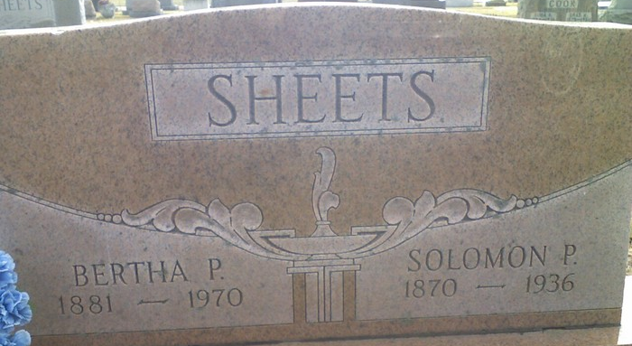
Photo by James Cross Jr

Solomon Sheets
in the Indiana, U.S., Death Certificates, 1899-2017
Name Solomon Sheets
Gender Male
Race White
Marital Status Married
Age 65
Birth Date 7 Jul 1870
Birth Place Indiana
Death Date 24 Jan 1936
Death Place Root, Adams, Indiana, USA
Death Registration Date 1936
Father Noah Sheets
Mother Sarah [Pryor]
Spouse Bertha
Informant Chauncey Sheets; Decatur, Indiana
Burial January 26, 1936; Decatur Cemetery

