Sharon Ann (Fickle) Sheets
June 25, 1944 – September 7, 2021

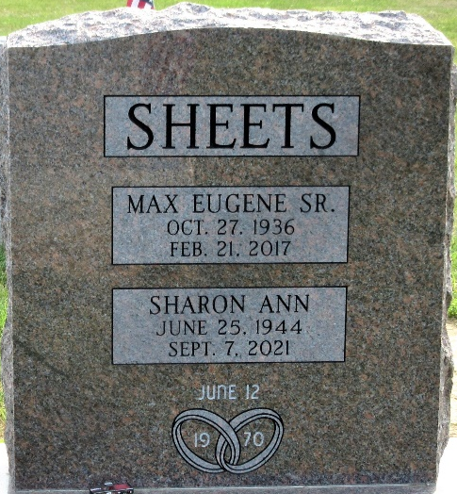
Photo by PLS

Sharon A. Sheets, 77, of Decatur, Indiana passed away Tuesday, September 7, 2021, at her residence. She was born on June 25, 1944 in Fort Wayne, Indiana. On June 12, 1970, she married Max Eugene Sheets, Sr. and he preceded her in death on February 21, 2017.
Sharon was a homemaker. She loved to sew and quilt. She also enjoyed doing crosswords and word searches. Sharon loved spending time with her family and enjoyed having fun. She was ornery.
She is survived by five daughters, Melvina Sheets Buckner, Christine (Lee) Pamer and Faye Taylor all of Decatur, Indiana, Theresa Bodle Spencer and Sally Sheets both of Lima, Ohio; two sons, David Bodle and Max (Wanda) Sheets, Jr. of Lima, Ohio; sister, Linda (Lynn) Dager of Decatur, Indiana; 15 grandchildren, 23 great-grandchildren, and six great-great-grandchildren.
She was preceded in death by two great-grandchildren, Cristain Mata and Weldon Pamer; a daughter, Maxine Shaffer; three brothers, David Fickle, Bud Geeting, and Mike Geeting; and sister, Carolyn Haley.
Private family services will be held.
Zwick & Jahn Funeral Home, Adams County, Indiana
September 8, 2021

