Ruth Margaret (Bushong) Sheets
June 20, 1917 – March 21, 2008

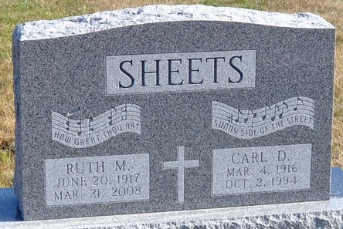
Photo by Deb Curry

Ruth M. Sheets, 90, of Decatur, died Friday, March 21, 2008, 7:22 a.m., at Adams Memorial Hospital. She married Carl D. Sheets on Dec. 21, 1940, in Lima, Ohio; he preceded her in death on Oct. 2, 1994.
Surviving are her daughter, Mrs. David (Sharron) Liby of Decatur; sons, Gary W. Sheets of Decatur and Denny R. (Trish) Sheets of Fort Wayne; four sisters; eight grandchildren; and 18 great-grandchildren. She was preceded in death by four brothers; and one sister.
Service is 10:30 a.m. Tuesday at Zwick & Jahn Funeral Home, Decatur, with visitation one hour prior to the service. Visitation also from 4 to 8 p.m. today at the funeral home. Preferred memorials to St. Mark's United Methodist Church.

News-Sentinel, Allen County, Indiana
Monday, March 24, 2008

**
Ruth M. Sheets

Ruth M. Sheets, 90 years old of Decatur, Indiana, passed away at 7:22 a.m. on Friday, March 21, 2008 in the Adams Memorial Hospital located in Decatur, Indiana. Ruth was born on Wednesday, June 20, 1917 in Cairo, Ohio the daughter of the late Walter Bushong and the late Bernice (Lewis) Bushong. She married the late Carl D. Sheets on December 21, 1940 in Lima, Ohio and he passed away on October 2, 1994.
Ruth was a member of the St. Mark's United Methodist Church in Decatur; the St. Mark's Missionary Society; and the Mary's Circle at the church. Ruth had formerly worked at the Galley Restaurant in Decatur, Indiana and also at the Decatur Community Center.
Surviving are her daughter, Mrs. David (Sharon) Liby of Decatur, Indiana, son, Gary W. Sheets of Decatur, Indiana, son, Denny R. (Trish) Sheets of Fort Wayne, Indiana, sister, Helen Walker of Lima, Ohio, sister, Patricia Nigh of Lima, Ohio, sister, Julia (Bill) McClain of Lima, Ohio, sister, Betty (Emil) Gratz of Hudson, Wisconsin, eight grandchildren, and eighteen great-grandchildren. Preceding Ruth in death were four brothers, Ray, Harry, Walter, and Ed Bushong; and one sister, Norma Burkholder.
Funeral services will be held at 10:30 a.m. Tuesday, March 25, 2008 in the Zwick & Jahn Funeral Home, Decatur, Indiana with the Rev. Fuhrman Miller and Rev. Jay Carter officiating. Interment will follow in the Decatur Cemetery. Friends will be received from 4-8 p.m. Monday, March 24, 2008 in the Zwick and Jahn Funeral Home, Decatur, Indiana and one hour prior to the service at the funeral home on Tuesday.
Preferred memorials are to St. Mark's United Methodist Church.

Zwick & Jahn Funeral Home, Adams County, Indiana
March 22, 2008

