Robert J. Sheets
April 21, 1921 – March 20, 1986

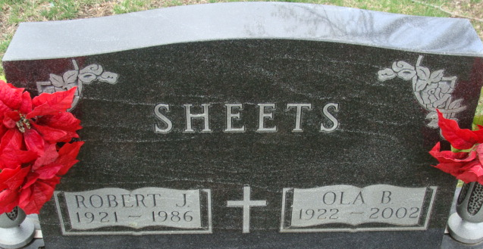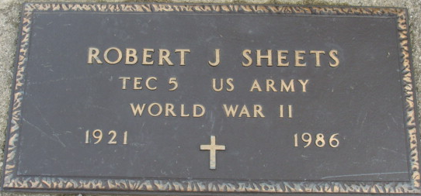
Photo by Alicia Kneuss

Robert J Sheets, 64 of Decatur, who retired in 1983 from Decatur General Electric Co., died at 11:50 p.m. Thursday at Lutheran Hospital, Fort Wayne following a brief illness.
He attended St. Mark's United Methodist Church and was a member of GE Quarter Century Club. Born in Adams County on April 21, 1921, he was the son of Don and Ethel (Wynn) Sheets and was married to Ola Kistler on November 9, 1950; she survives.
Also surviving are two daughters, Mrs. Daniel (Barbara) Butcher and Mrs. Kevin (Becky) Cochran both of Decatur; two brothers, Glenn Sheets, Belleville, Ill. and Buddy Sheets, Decatur; three sisters, Mrs. Katherine Warren, Fort Wayne, Betty Sheets and Mrs. Elizabeth Mc Cullough both of Decatur; and three grandchildren. Two brothers preceded in death.
Services will be held at 1:30 p.m. Monday at Winteregg-Linn & Haggard Funeral Home, Rev. James Hook and Rev. Jerry Densmore officiating. Burial will be in Decatur Cemetery. Friends may call at the funeral home after 7 p.m., after 10 a.m. Sunday, and Monday from 9:30 a.m. until time of services.

Winteregg-Linn & Haggard Funeral Home, Adams County, Indiana
March 21, 1986

**
Indiana, U.S., Death Certificates, 1899-2017
Name Robert J Sheets
Gender Male
Race White
Marital Status Married
Age 64
Birth Date 21 Apr 1921
Birth Place Indiana
Death Date 20 Mar 1986
Death Place Fort Wayne, Allen, Indiana, USA
Father Don Sheets
Mother Ethel Wynn
Spouse Ola Kistler
Informant Ola Sheets; wife; Decatur, Indiana
Burial March 24, 1986; Decatur Cemetery; Decatur, Indiana

