Richard Earl Sheets
March 16, 1918 – January 11, 2003

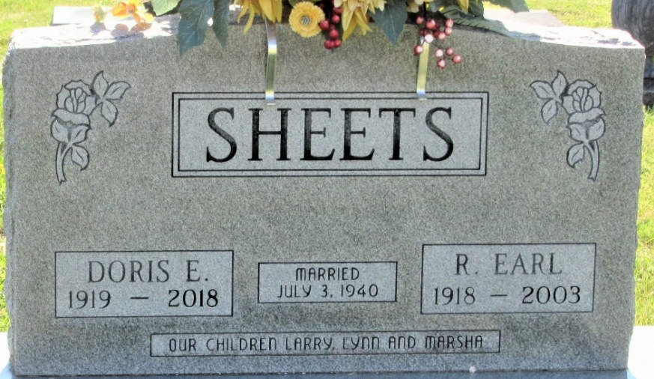
Photo by PLS

R. Earl Sheets, 84, of Decatur, a longtime businessman in Decatur, died at 4:33 a.m. Saturday at Woodcrest Nursing Center.
He was born March 16, 1918 in Wren, Ohio, to Addison A. and Lucy S. Hoffman Sheets and married Doris E. Durbin on July 3, 1940, she survives.
He owned Farmers Grain Company in Willshire, Ohio from 1948-56, then he and his wife owned and operated Sheets Furniture in Decatur from 1957-76. He served as president of the Decatur Chamber of Commerce in 1965.
Mr. Sheets was a member of First United Methodist Church in Decatur and served on many of its boards. During World War II, he was in the U.S. Army.
Other survivors are two sons, Larry R. Sheets of Lima, Ohio and Lynn A. Sheets of Defiance, Ohio; a daughter, Mrs. Douglas (Marsha) Worthington of Fort Wayne; a brother, Carl E. Sheets of Fort Wayne; seven grandchildren and fourteen great-grandchildren. A brother and sister are deceased.
Funeral services will be held at 11 a.m. Tuesday in the First United Methodist Church of Decatur, with burial in Decatur, including military graveside rites by the color guard of American Legion Post 43 in Decatur. Visiting hours are until 8 p.m. today in Haggard and Sefton Funeral Home, Decatur, and 10-11 Tuesday in the church.
Preferred memorials are to the church.

Decatur Daily Democrat, Adams County, Indiana
Saturday, January 11, 2003

