Richard A. Sheets
January 4, 1929 – March 10, 1986

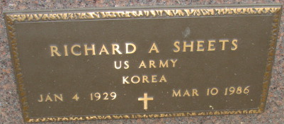
Photo by Alicia Kneuss

Richard A Sheets
in the Indiana, U.S., Death Certificates, 1899-2017

Name Richard A Sheets
Gender Male
Race White
Marital Status Never Married (Single)
Age 57
Birth Date 4 Jan 1929
Birth Place Indiana
Death Date 10 Mar 1986
Death Place Marion, Grant, Indiana, USA
Death Registration Date 1986
Father Donald Sheets
Mother Ethel Wynn
Informant VA Medical Center records; Marion, Indiana
Burial March 13, 1986; Decatur Cemetery; Decatur, Indiana

