Reba G. (Brown) Sheets
January 23, 1912 – November 19, 1993

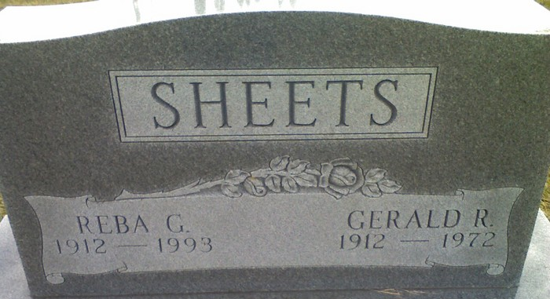
Photo by James Cross Jr

Reba G. Sheets, 81, Decatur, died on Friday at Lakeside Manor Nursing Home. She was born in Decatur on January 23, 1912 to Dwight and Elizabeth Bushnell-Brown and married Gerald R. Sheets on Sept. 18, 1938. He died on September 21, 1972.
She was a homemaker and a member of Decatur Church of God, but formerly attended Union Chapel United Methodist.
Surviving are two sons, Ron and John Sheets, both of Decatur; one daughter, Naomi Jester, Warsaw, Indiana; one sister, Mildred I. Hakes, Decatur; one brother, Waldo "Jim" Brown, Bristol, Indiana; four grandchildren and four great-grandchildren. Two brothers, Marion and Orlan Brown; one sister Flava Brown and one grandson are deceased.
Funeral services will be at 3 p.m. Tuesday in Zwick-Sefton & Jahn Funeral Home, Decatur, with Revs. Sandy Hildebrand and Robert Linton officiating. Burial will be in Decatur Cemetery. Visiting hours will be from noon - 3 p.m. Tuesday in the funeral home.
Preferred memorials are to the donor's choice.

Decatur Daily Democrat, Adams County, Indiana
Monday, November 22, 1993

