Raymond E. Sheets
October 13, 1920 – October 9, 1944

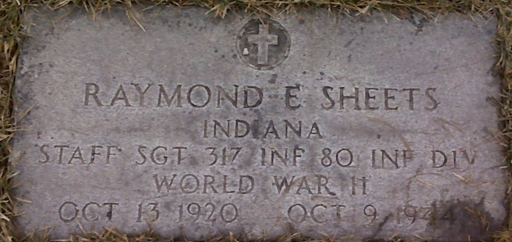
Photo by Lee Sheets

Staff Sgt. Raymond E. Sheets Is Killed in Action in France

Staff Sgt. Raymond E. Sheets, 23-year-old son of Mr. and Mrs. Noah T. Sheets, 257 North Seventh Street, was killed in action in France on October 9, the parents were notified by the War Department last night. He was an infantryman and was attached to Company G of the 319th Infantry. He would have been 24 years old on October 13.
S/Sgt. Sheets entered the Army on July 15, 1942. He took basic training at Camp Forrest, Tenn., and specialized training at Camp Riley and Camp Phillips, Kan., Phoenix, Ariz., and Fort Dix, N.J. before going overseas last June. He landed in England and then went to France shortly after the invasion.
Born in Decatur, S/Sgt. Sheets, graduated from the Decatur High School in 1940. Prior to joining the Armed Forces, he was employed by the Decatur Floral Company.
Besides the parents, he is survived by four brothers, two of whom are in the Army. They are T/5 Doyle Sheets, a Signal Corpsman stationed in Germany; Pvt. Robert Sheets, Fort Lawton, Wash., Richard and David Sheets at home; and three sisters, Mrs. Clarence Morgan of North Seventh Street, whose husband is also in the Army; Alice and Martha Sheets, at home.

Adams County Historical Museum, Adams County, Indiana
July 1944 – March 1945 Scrapbook, image 51
Handwritten date: Monday, October 30, 1944

