Addie Belle (McGill) Sheets-Pitser
May 21, 1877 – September 27, 1963

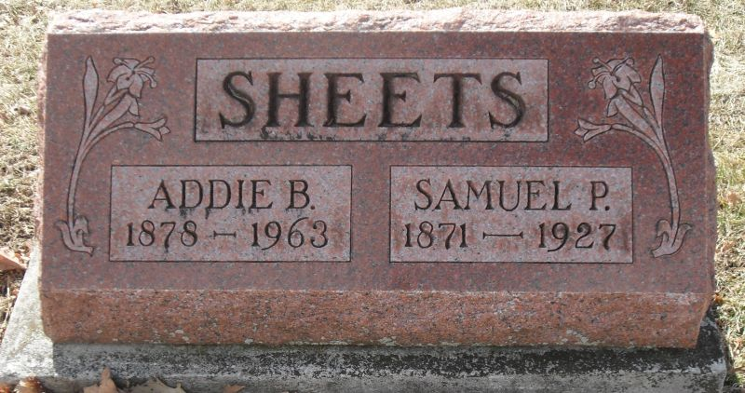
Photo by Stephen & Andrea Brangan

Funeral Monday for Mrs. Pitser

Funeral services for Mrs. Addie Sheets Pitser, 86, of 604 N. Third Street, will be held Monday at 1:30 p.m. at the Zwick Funeral Home, the Rev. Fuhrman Miller officiating. Mrs. Pitser died suddenly Friday noon of a heart attack.
The daughter of Charles G. and Catherine Ann Gates McGill, she was born in Middlebury, O., May 21, 1877. She was married to Samuel P. Sheets on Dec. 24, 1893. He died Feb. 19, 1927.
On Jan. 23, 1932, she was married to D. E. Pitser, who died October 19, 1947. Her children and grandchildren had spent the past year remodeling her present home for her, and she just moved in this summer. The attack was sudden and unexpected, and she was taken to the Adams County Memorial Hospital, where she lived one hour. She was a member of the Christian Church.
Survivors include the following children: Dwight L. Sheets, Decatur; Fred C. Sheets, South Bend; Mrs. Fred (Esther) McConnell, Harry S. Sheets, Everett P. Sheets, Rex H. Sheets all of Decatur; R. D. L., of Jeffersonville. One son, Raymond O. Sheets, is deceased. There are 15 grandchildren, 14 great-grandchildren, two stepchildren, Mrs. Bertha Souers, Huntington, and Glen Pitser, Fort Wayne; and one sister, Mrs. Edmund (Isabelle) Kiser, of Decatur.
Friends may call at the Zwick Funeral Home after 7 p.m. tonight. Burial will be in the Decatur Cemetery.

Berne Library Heritage Room, Adams County, Indiana
Adams County Obits 1962-1964
Handwritten date: Saturday, September 28, 1963

**
Indiana, U.S., Death Certificates, 1899-2017
Name Addie Pitser
Gender Female
Race White
Marital Status Widowed
Age 86
Birth Date 21 May 1877 [sic]
Birth Place Ohio
Death Date 27 Sep 1963
Death Place Decatur, Adams, Indiana, USA
Death Registration Date 1963
Father Charles G Mc Gill
Mother Catherine Ann Gates
Informant Mrs. Fred McConnell; daughter; Decatur, Indiana
Burial September 30, 1963; Decatur Cemetery; Decatur, Indiana

