Perry L. Sheets
February 15, 1937 – April 20, 2016

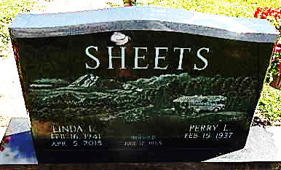
Photo by Alicia Kneuss

Perry L. Sheets, 79, of Decatur, Indiana, passed away on Wednesday, April 20, 2016 at the Visiting Nurse & Hospice Home in Ft. Wayne. He was born on February 15, 1937 to the late Everett and Florence (Schindler) Sheets. On June 12, 1965, he married Linda L. Reber and for 49 years they were married until she passed away on April 5, 2015.
He was a 1955 graduate of Decatur High School and served his country in the United States Marine Corps. He first worked at Bag Service in Decatur, where he met his wife, Linda. He then was employed by Dolco Packaging, where he worked as a Leadman in Extrusion from 1972, until he retired in 2002, after 30 years of service. He was also a member of the American Legion Post #43.
Perry was a loving husband, father, and grandfather and also enjoyed traveling and camping. Perry is survived by a son, Tyler (Kris) Sheets, Decatur, and a grandson, Austin Sheets. He was also preceded in death by a sister, Janelle (Price) Liechty and a brother, John Sheets.
Visitation will be held on Sunday, April 24, 2016, from 11:00 a.m. to 3:00 p.m. at Haggard-Sefton & Hirschy Funeral Home. A Funeral Service will be held at 10:30 a.m. on Monday, April 25, 2016, also at the Funeral Home. Burial will take place in the Decatur Cemetery, where Military Graveside Rites will be conducted by the American Legion Post #43 Color Guard.
Memorial contributions may be made to the American Legion Post #43 Color Guard or the Visiting Nurse & Hospice Home.

Haggard-Sefton & Hirsch Funeral Home, Adams County, Indiana
April 22, 2016

