Ola B. (Kistler) Sheets
January 28, 1922 – April 13, 2002

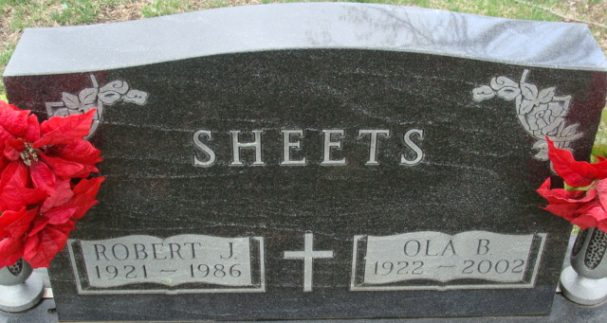
Photo by Alicia Kneuss

Ola B. Sheets, 80, of Decatur, a member of Linn Grove Calvary United Methodist Church, and St. Mark's United Methodist Church, died Saturday, April 13, 2002, at Adams County Memorial Hospital.
The Waterloo native was a homemaker and worked for 42 years at General Electric, Decatur.
She was a member of St. Mark's United Methodist Church Choir, General Electric Gecode Club and choir.
Surviving are daughters Barbara Butcher and Becky Cochran, both of Decatur; sisters Esther Morgan of Decatur and Nina Wittwer of Berne; brothers Marvin T. Kistler of Portland, and Rev. Norman S. Kistler of Lima, Ohio; three grandchildren; and a step grandchild. She was preceded in death by her husband, Robert J., and three brothers.
Services are 11 a.m. Wednesday at St. Mark's United Methodist Church, Decatur, with calling one hour before services. Calling is also from 4 to 9 p.m. Tuesday at Haggard & Sefton Funeral Home, Decatur. Burial will be at Decatur Cemetery.
Memorials are to both churches.

News-Sentinel, Allen County, Indiana
Monday, April 15, 2002

**
Indiana, U.S., Death Certificates, 1899-2017

Name Ola B Sheets [Ola B Kistler]
Gender Female
Race White
Marital Status Widowed
Age 80
Birth Date 28 Jan 1922
Birth Place Waterloo, Indiana
Death Date 13 Apr 2002
Death Place Decatur, Adams, Indiana, USA
Father James Kistler
Mother Lavanga A Vangundy
Informant Mrs. Barbara A. Butcher; daughter; Decatur, Indiana
Burial April 17, 2002; Decatur Cemetery; Decatur, Indiana

