Norman Lewis Sheets
May 7, 1932 – November 11, 1981

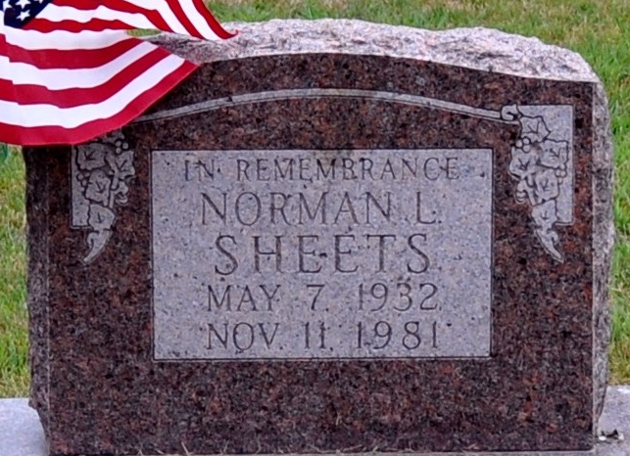
Photo by Deb Curry

Norman Lewis Sheets
in the Indiana, U.S., Death Certificates, 1899-2017
Name Norman Lewis Sheets
Gender Male
Race White
Marital Status Never Married (Single)
Age 49
Birth Date 7 May 1932
Birth Place Indiana
Death Date 11 Nov 1981
Death Place Bluffton, Wells, Indiana, USA
Death Registration Date 1981
Father Chauncey A. Sheets
Mother Margaret Kidwell
Informant Brice Sheets; brother; Decatur, Indiana
Burial November 13, 1981; Decatur Cemetery; Decatur, Indiana

