Nelle (Hitchcock) Sheets
February 24, 1906 – October 27, 1997

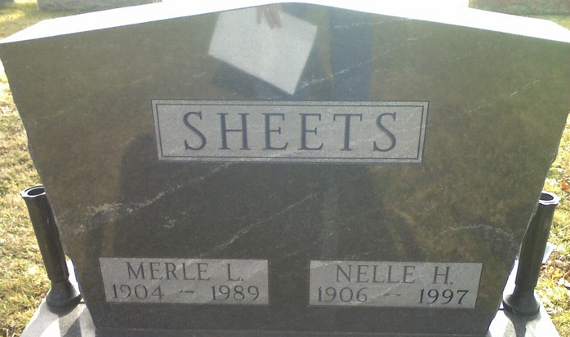
Photo by James Cross Jr

Nelle H. Sheets, 91, Fort Wayne, a former resident of Decatur, died Monday in Hospice Home of Northeast Indiana.
Among survivors are a son and a daughter. Her husband, Merle Sheets, died in 1989.
Funeral services will be held at 10 a.m. Saturday in First Wayne Street United Methodist Church, Fort Wayne, with burial in Decatur Cemetery. Visiting hours are 2-4 and 6-8 p.m. Friday in Klaehn, Fahl and Melton Funeral Home on Wayne St. in Fort Wayne.

Decatur Daily Democrat, Adams County, Indiana
Tuesday, October 28, 1997

**
Indiana, U.S., Death Certificates, 1899-2017
Name Nelle Sheets
[Nelle Hitchcock]
Gender Female
Race White
Marital Status Widowed
Age 91
Birth Date 24 Feb 1906
Birth Place Van Wert County, Ohio
Death Date 27 Oct 1997
Death Place Fort Wayne, Allen, Indiana, USA
Death Registration Date 1997
Father William Hitchcock
Mother Minnie Watt
Informant Mae Bell Havens; daughter; Fort Wayne, Indiana
Burial November 1, 1997; Decatur Cemetery; Decatur, Indiana

