Nancy (Thompson) Sheets
April 2, 1851 – November 4, 1927

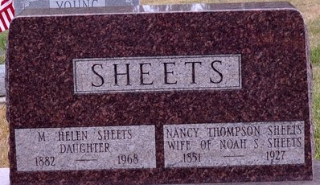
Photo by Deb Curry

Nancy Thompson from tree Sheets/Harman family tree
Birth 2 Apr 1851 Upper Sandusky, Wyandot, Ohio, USA
Marriage 5 Nov 1881 Upper Sandusky, Wyandot, Ohio, USA
Residence 1921 Fort Wayne, Allen, Indiana, USA
Death 4 Nov 1927 Indiana, USA
Father Edward Thompson (1800-1879)
Mother Dianah McKendry (1824-1862)
Spouse Noah Solomon Sheets (1843-1907)

