Merle L. Sheets
July 16, 1904 – October 28, 1989

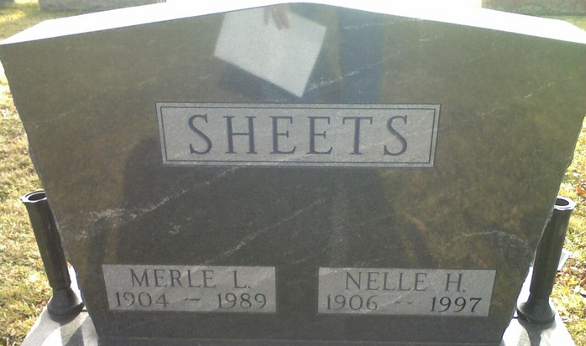
Photo by James Cross Jr

Merle L. Sheets, 85, died Saturday in Lutheran Hospital.
The Adams County native was a farmer and 1968 retiree of General Electric Co., Decatur. He was a member of First Wayne Street United Methodist Church.
Surviving is his wife, Nelle A.; a daughter, Mae Belle Havens of Fort Wayne; a son, Ralph E. of Fort Wayne; 11 grandchildren; and 12 great-grandchildren.
Services are 10:30 a.m. tomorrow in the church, with burial in Decatur Cemetery, Decatur. Calling is 3 to 5 and 7 to 9 p.m. today in Klaehn’s Chalfant-Perry Chapel, 2423 Fairfield Ave.

Fort Wayne News Sentinel, Allen County, Indiana
Monday, October 30, 1989
**
Indiana, U.S., Death Certificates, 1899-2017
Name Merle L Sheets
Gender Male
Race White
Age 85
Marital Status Married
Birth Date 16 Jul 1904
Birth Place Adams County, Indiana
Death Date 28 Oct 1989
Death Place Fort Wayne, Allen, Indiana, USA
Death Registration Date 1989
Father Solomon Sheets
Mother Bertha Rinehart
Spouse Nelle A Hitchcock
Informant Nelle A. Sheets; wife; Fort Wayne, Indiana
Burial October 31, 1989; Decatur Cemetery; Decatur, Indiana

