Melvena Mae (Smitley) Sheets
October 9, 1910 – November 30, 1963

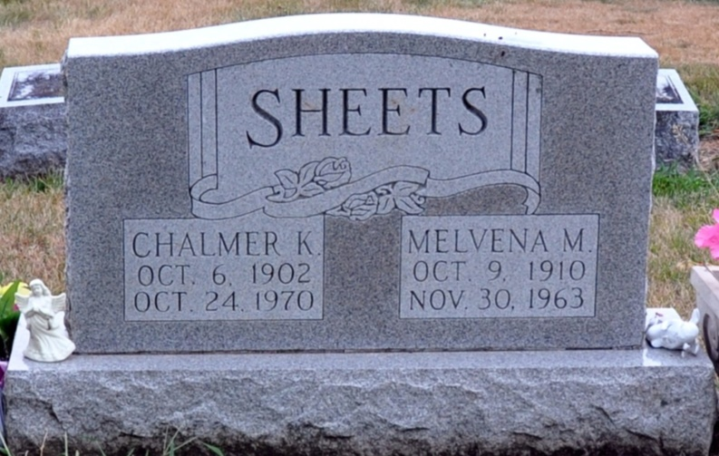
Photo of Alicia Kneuss

MRS. CHALMER SHEETS DIES SATURDAY NIGHT

Mrs. Melvena Sheets, 53, wife of Chalmer K. Sheets of Decatur route 5, died at 6:50 p.m. Saturday at the Adams County Memorial Hospital following an extended illness. She was born in Adams County Oct. 9, 1910, a daughter of John and Edna Smitley and was married to Chalmer K. Sheets March 21, 1930.
Mrs. Sheets was a member of the Union Chapel Evangelical United Brethren Church.
Surviving are her husband; her mother, Mrs. Edna Smitley; seven daughters: Mrs. Homer (Delores) Tschannen, Mrs. Jack (Josephine) Weldy, Mrs. Don (Esther) Peterson and Mrs. Jerry (Carolyn) Fry, all of Decatur; Mrs. John (Betty) Haverholser of Hicksville, O., Mrs. William (Mary) McCarty of Cutler?, and Mrs. Richard (Sally) McDongough of Lima, O.; three sons, Max Sheets of LaGrange; Lester Sheets of Monroe, and Jay Sheets of Decatur; 33 grandchildren and two brothers, the Rev. Keith Smitley of Kewanna, Ill., and John Smitley of Fort Wayne. One daughter and one brother are deceased.
Funeral services will be conducted at 1:30 p.m. Tuesday at the Union Chapel Evangelical United Brethren Church, with the Rev. Kenneth Angle officiating. Burial will be in the Decatur Cemetery. Friends may call at the Zwick Funeral Home until 11:30 a.m. Tuesday. The body will lie in state at the church from 12:30 p.m. Tuesday until time of the services.

Decatur Daily Democrat, Adams County, Indiana
Monday, December 2, 1963

**
MRS. SHEETS DIES

Mrs. Chalmer (Melvena) Sheets, 53, of Decatur Route 5, mother of seven daughters and three sons, died Saturday at the Decatur Hospital.
Services were held this afternoon at the Union Chapel Evangelical United Brethren Church with burial in the Decatur Cemetery.
One of the sons is Lester Sheets of Monroe.

Bluffton News Banner, Wells County, Indiana
December 3, 1963

