Max Eugene Sheets, Sr.
October 27, 1936 – February 21, 2017

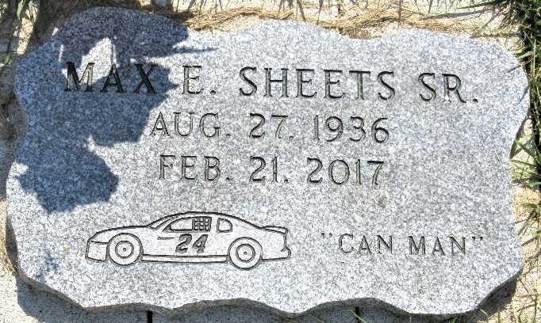
Photo by PLS

Max E. Sheets Sr., 80 years old of Decatur, Indiana, passed away on Tuesday, February 21, 2017 at his residence following an extended illness. Max was born on Thursday, October 27, 1936 in Decatur, Indiana the son of the late Chalmer Sheets and the late Melvina (Smitley) Sheets. Max was united in marriage to Sharon Fickle on June 12, 1970 in Decatur, Indiana.
He was a former member of the Union Chapel United Methodist Church in Decatur where his family was raised.
Max had a very diverse employment history. He was a farmer at Bookout Farms in Decatur, a mechanic for Duff Truck Line, and a truck driver. He may have been most remembered as the "Can Man" in Lima, Ohio as he collected cans and was often seen at Allen County Recycles (ACR).
Max is survived by his wife of 46 years, Sharon Sheets of Decatur, IN; daughter, Melvina Buckner of Decatur, IN; daughter, Christine (Lee) Pamer of Decatur, IN; son, David Bodle; daughter, Theresa "Spencer" Bodle of Lima, OH; daughter, Faye Taylor of Decatur, IN; son, Max (Wanda) Sheets Jr. of Lima, OH; daughter, Sally Sheets of Lima, OH; sister, Carolyn (Richard) Marbaugh of Decatur, IN; sister, Mary McCarthy of Flora, IN; 15 grandchildren; 19 great-grandchildren; and four great-great-grandchildren.
Preceding Max in death was a daughter Maxine Shaffer; two brothers, Jay Sheets and Lester Sheets; six sisters, Esther Peterson, Josephine Weldy, Sally McDonough, Dolores Tschannen, Betty Overholser, and Faye Ann Sheets.
Friends will be received from 6 to 8p.m. Friday, February 24, 2016 at the Zwick & Jahn Funeral Home in Decatur. There will be no funeral services. Burial will follow at a later date at Decatur Cemetery.
In lieu of flowers, memorial contributions can be made to the family.

Zwick & Jahn Funeral Home, Adams County, Indiana
February 22, 2017
**

Indiana, U.S., Birth Certificates, 1907-1944
Name Max Eaugene Sheets
Gender Male
Birth Date 27 Oct 1936
Birth Place Root, Adams, Indiana, USA
Father Chalmer K. Sheets; age 34
Mother Melvinane May Smithly; age 26; 6th child; all living
Certificate Number 40680
Roll number 40474_357233
Volume Range 81 – 85

