Marianne E. (Klarowski) Sheets
September 25, 1921 – January 31, 1992

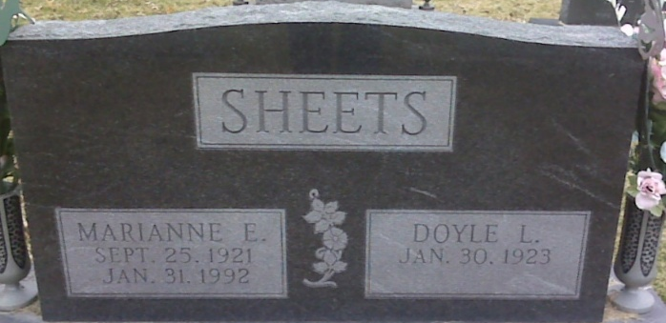
Photo by Lee Sheets

Marianne E. Sheets, 70, of Fort Wayne, died yesterday at Lutheran Hospital. The Algoma, Wis., native had lived in Fort Wayne most of her life. She was a homemaker and a World War II veteran.
Surviving are her husband, Doyle L.; daughter Kathleen A. Ehinger of Fort Wayne; son Ronald D. of Fort Wayne; sisters Frances Goetz of Green Bay, Wis., and Helen Winkler of Clouis, Calif.; and seven grandchildren.
Services are 9:30 a.m. Monday at Elzey & Haggard Home for Funerals, 6810 Old Trail Road, and 10 a.m. at St. Henry's Catholic Church, 2929 E. Paulding Road. Calling is 7 to 9 p.m. today and 2 to 5 and 7 to 9 p.m. tomorrow at the funeral home. Wake services are at 7:30 p.m. tomorrow. Burial will be in Decatur Cemetery, Decatur, with military rites.
Preferred memorials are gifts to the church or St. Vincent DePaul Society.

News-Sentinel, Allen County, Indiana
Saturday, February 1, 1992
**
Indiana, U.S., Death Certificates, 1899-2017
Name Marianne E Sheets
[Marianne E Klarowske]
Gender Female
Race White
Age 70
Marital Status Married
Birth Date 25 Sep 1921
Birth Place Algoma, Wisconsin
Death Date 31 Jan 1992
Death Place Fort Wayne, Allen, Indiana, USA
Death Registration Date 1992
Father August Klarowske
Mother Frances Serovey
Spouse Doyle L Sheets
Informant Doyle Sheets; husband; Fort Wayne, Indiana
Burial February 3, 1992; Decatur Cemetery; Decatur, Indiana

