Margaret (Kidwell) Sheets
February 23, 1902 – August 11, 1955

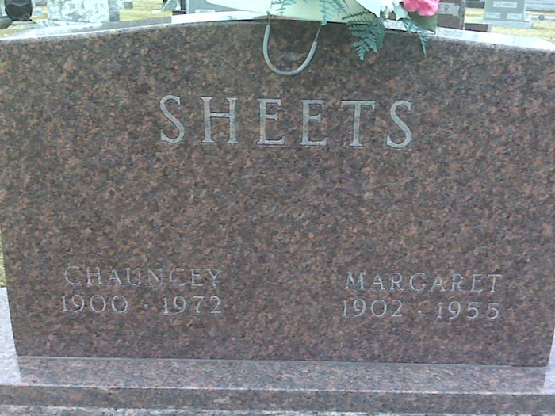
Photo by Lee Sheets

Mrs Margaret Sheets
in the Indiana, U.S., Death Certificates, 1899-2017
Name Mrs Margaret Sheets
[Mrs Margaret Kidwell]
Gender Female
Race White
Age 53
Marital Status Married
Birth Date 23 Feb 1902
Birth Place Indiana
Death Date 11 Aug 1955
Death Place Rural, Adams, Indiana, USA
Death Registration Date 1955
Father Robert Kidwell
Mother Laura Neff
Informant Chansey Sheets; Decatur, Indiana
Burial August 14, 1955; Decatur Cemetery; Decatur, Indiana

