M. Helen Sheets
May 10, 1882 – January 28, 1968

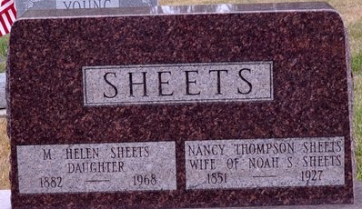
Photo by Deb Curry

Helen Sheets
in the Indiana, U.S., Death Certificates, 1899-2017
Name Helen Sheets
Gender Female
Race White
Age 85
Marital Status Never Married (Single)
Birth Date 10 May 1882
Birth Place Indiana
Death Date 28 Jan 1968
Death Place Fort Wayne, Allen, Indiana, USA
Death Registration Date 1968
Father Noah S Sheets
Mother Nancy Thompson
Informant Mrs. Don Harmon; niece; Decatur, Indiana
Burial January 31, 1968; Decatur Cemetery; Decatur, Indiana

