Lloyd M. Sheets
October 7, 1914 – May 27, 2007

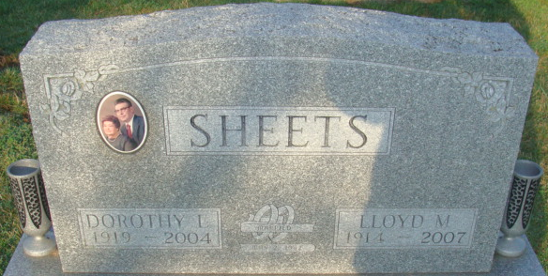
Photo by Alicia Kneuss

Lloyd M. Sheets, 92 years old of Decatur, Indiana, passed away on Sunday, May 27, 2007 in the Adams Memorial Hospital where he had been a patient for two weeks.
He was born on Wednesday, October 7, 1914 in Van Wert County, Ohio the son of the late Jess E. Sheets and the late Addie V. (Woods) Sheets. He married the late Dorothy E. Sheets on May 2, 1942 and she passed away on November 17, 2004.
Lloyd was a member of Union Chapel United Methodist Church. He was also a life member of the Decatur Moose Lodge #1311 and the Legion of the Moose. He retired from Central Soya Company on February 26, 1975 with 38 years of service.
Surviving are his nieces & nephews.
Preceding Lloyd in death were two sisters, Helen Milheim & Delsie Nishiyama and three brothers, Lester, Lewis & Leo Sheets.
Funeral services will be held at 11:00 a.m. Thursday, May 31, 2007 in the Zwick & Jahn Funeral Home with Rev. Ed Karges officiating. Interment will follow in the Decatur Cemetery. Friends will be received from 4:00 p.m. to 8:00 p.m., Wednesday, May 30 in the Zwick & Jahn Funeral Home. There will be a Moose Memorial Service conducted at 8:00 p.m. following visitation.
Preferred memorials are to American Lung Association.

Zwick & Jahn Funeral Home, Adams County, Indiana
May 28, 2007

