Linda L. (Reber) Sheets
February 16, 1941 – April 5, 2015

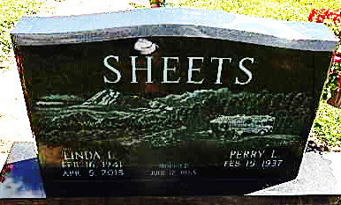
Photo by Alicia Kneuss

Linda L. Sheets, 74, of Decatur, IN passed away at 6:30 p.m. on Sunday, April 5, 2015 at her residence. She was born on February 16, 1941 in Chicago, IL to the late Chalmer L. and Florence (Rodgers) Reber. On June 12, 1965 she married Perry L. Sheets.
She was a 1959 graduate of Adams Central High School and a graduate of Fort Wayne International Business College. She worked in the office at Bag Service in Decatur, where she met her husband. After they married she spent the rest of her life as a homemaker.
Linda was a loving wife, mother, and grandmother and also enjoyed traveling and camping.
She is survived by her husband of 49 years Perry L. Sheets of Decatur; her son Tyler (Kris) Sheets of Decatur; her grandson Austin Sheets.
Visitation will be from 3:00 - 8:00 p.m. on Friday, April 10, 2015 at Haggard-Sefton & Hirschy Funeral Home. A Private Funeral Service will be held on Saturday, April 11, 2015 with a Private Graveside Service to follow in the Decatur Cemetery.
Memorials may be made to Family Life Care.

Haggard-Sefton & Hirschy Funeral Home, Adams County, Indiana
April 6, 2015

