Linda Kay Sheets
May 17, 1954 – May 17, 1954

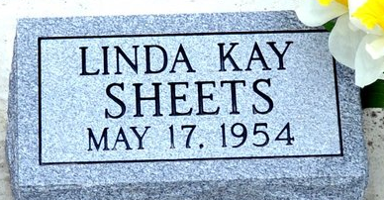
Photo by Deb Curry

Linda Kay Sheets from BIRD FAMILY TREE
Father Brice Franklin Sheets
Mother Vera Louise Cottrell
Birth 17 May 1954
Death 17 May 1954

