Lester Lee Sheets
January 5, 1938 – March 10, 2016

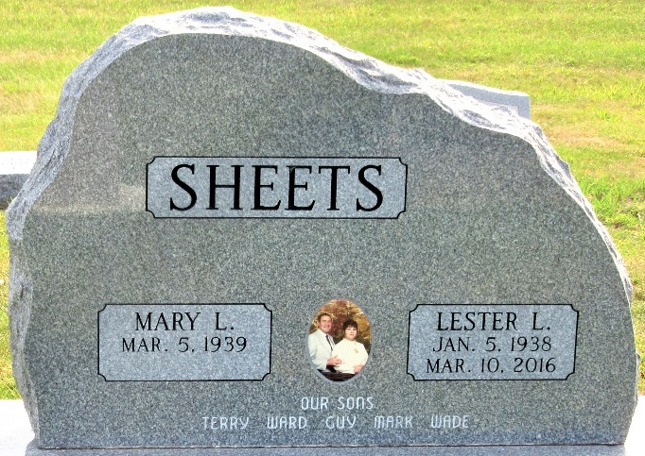
Photo by PLS

Lester Lee Sheets, 78 years old of Decatur, Ind., passed away on Thursday, March 10, 2016 at Adams Memorial Hospital. He was born on Wednesday, January 5, 1938 in Decatur, Indiana the son of the late Chalmer Sheets and the late Melvina (Smitley) Sheets. He married Mary L. Knittle on January 20, 1957 in Jay County, Indiana.
Lester was a member of Union Chapel United Methodist Church where he served as the superintendent of Sunday school and supervised the tape ministry. He also did visitation of shut-ins. He was previously in the Monroe Lion's Club and Moose Lodge #1311.
He was a graduate of Pleasant Mills High School in 1956 and retired from Dunbar Furniture in 1991. Lester was a longtime loyal Cub's fan, but never saw them win a World Series. He also enjoyed watching IU Basketball, Chicago Bears and Indianapolis Colts football.
He was a very good husband, father, grandfather, & great-grandfather. He helped his wife, Mary, babysit and made the kids mind.
Surviving are his wife, Mary L. Sheets of Decatur; son, Terry (Kay) Sheets of Decatur; son, Ward Sheets of Decatur; son, Guy (Angi) Sheets of Monroe; son, Mark (Michelle) Sheets of Monroe; son, Wade (Kim) Sheets of Monroe; brother, Max Sheets of Decatur; sister, Mary McCarty of Cutler; sister, Carolyn (Richard) Marbaugh of Decatur; 16 grandchildren, and 23 great-grandchildren.
Preceding Lester in death were a brother, Jay Sheets; and six sisters, Faye Ann Sheets; Josephine Weldy; Esther Peterson; Dolores Tschannen; Betty Overholser & Sally McDonough.
Funeral services will be held at 10:30 a.m. Monday, March 14, 2016 in the Zwick & Jahn Funeral Home in Decatur with Pastor Ed Karges and Pastor Ernie Suman officiating. Interment will follow in the Decatur Cemetery. Friends will be received from 12 noon to 5 p.m., Sunday, March 13 in the Zwick & Jahn Funeral Home in Decatur and one hour prior to the service at the funeral home on Monday.

Zwick & Jahn Funeral Home, Adams County, Indiana
March 11, 2016

