Lester E. Sheets
August 27, 1916 – July 27, 1970

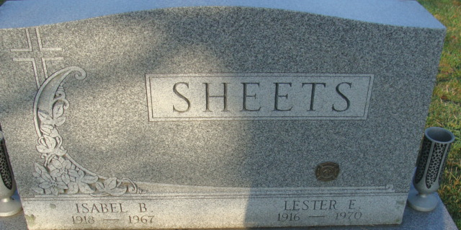
Photo by Alicia Kneuss

Lester E. Sheets Dies Last Evening
Lester E. Sheets, 53, of 322 North First Street, owner and operator of Sheets Garage, 1805 West Monroe Street, died Monday evening at Parkview Memorial Hospital, Fort Wayne, where he had been a patient since July 10. Mr. Sheets was an employee of the Clyde Butler Garage for 16 years and had operated his own business since January of 1962.
He was born in Van Wert County, O., Aug. 27, 1916, a son of Jesse and Addie Woods-Sheets, and was married to Isabel B. Sheehan Aug. 27, 1938. His wife preceded him in death June 2, 1967.
Mr. Sheets was a member of the First United Methodist Church, the Moose and Elks Lodges, and the Decatur Volunteer Fire Department. He served as governor of the Moose Lodge here in 1951.
Surviving is one son, Garry E. Sheets of Decatur; two daughters, Mrs. David (Peggy) Gay of Anderson, and Miss Linda Sue Sheets, at home; his father, Jesse Sheets of 957 Walnut Street; two sisters, Mrs. Miles (Delsie) Nishiymaha of Grand Rapids, Mich., and Mrs. Lendell (Helen) Milheim of Tecumseh, Mich.; one brother, Lloyd Sheets of Decatur; and one grandson, Scott Allen. Two brothers, Leo and Lewis Sheets, are deceased.
Funeral services will be conducted at 1:30 p.m. Thursday at the Zwick Funeral Home, with Rev. Melvin Seeger officiating. Burial will be in the Decatur Cemetery. Friends may call at the funeral home after 7 p.m. today until time of the services. Moose memorial service will be held at 7:30 p.m. Wednesday.

Decatur Daily Democrat, Adams County, Indiana
Tuesday, July 28, 1970

