Leona E. (Zwick) Sheets
November 3, 1904 – February 13, 1995

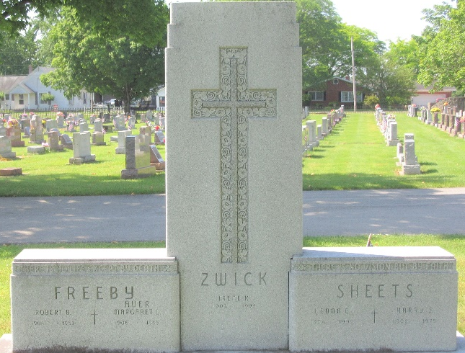
Photo by PLS

Leona E Sheets
in the Indiana, U.S., Death Certificates, 1899-2017
Name Leona E Sheets
[Leona E Zwick]
Gender Female
Race White
Age 90
Marital Status Widowed
Birth Date 3 Nov 1904
Birth Place Decatur, Indiana
Death Date 13 Feb 1995
Death Place Fort Wayne, Allen, Indiana, USA
Death Registration Date 1995
Father William H Zwick
Mother Clara Wischmeyer
Informant James A. Sheets; son; Fort Wayne, Indiana
Burial February 16, 1995; Decatur Cemetery; Decatur, Indiana

