Leo David Sheets
February 5, 1933 – May 15, 1953

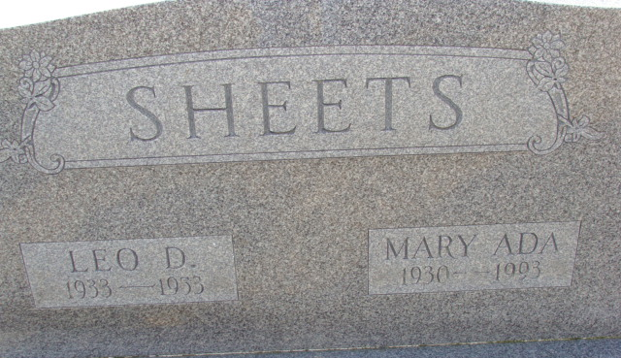
Photo by Alicia Kneuss

THREE PERSONS KILLED IN TRAFFIC MISHAP EAST OF DECATUR, ON HIGHWAY 224 THIS MORNING,
ONE OF VICTIMS IS LEO D. SHEETS, 20, DECATUR
Automobile Collision Fatal to Fort Wayne Man, Woman, Three Miles East of Decatur; Police Seeking Driver of Third Car Reported Involved in Fatal Accident

Three persons, two men and a woman, were killed almost instantly in a traffic mishap in which three automobiles were involved, three miles east of Decatur, on Highway 224, at 12:30 o'clock this morning.
The dead are: Leo D. Sheets, 20, of Decatur; Ralph W. VanOsdale, Jr., 32, Fort Wayne; Mrs. Mary Ellen Owen, 23, 7515 Bluffton Road
The three victims bring to eight, the number of people killed on Adams County highways this year.
Sheets suffered a fractured skull and internal injuries. He was pulled out of his burning car before the flames reached him. He died on the scene.
VanOsdale suffered a broken neck and a broken right leg. He died instantly.
Mrs. Owen, whose husband is in Japan with the U. S. Army, suffered a crushed pelvis and internal injuries. She died almost immediately.
According to Sheriff Bob Shraluka, a third car owned and believed driven by Dean Haggard, 26, of Ossian, was involved indirectly in the accident. Police are searching for Haggard and at noon today had not located him. He is said by witnesses to have been injured and his car was demolished. He is reported to have been cut badly and had blood streaming from his face. It is believed that he fled from the scene of the accident and despite a search by a number of policemen, he has not been located.
The ghastly wreck was investigated by Sheriff Shraluka and Deputy Jim Cochran, State Troopers Biberstein and Myers and Decatur policeman Jim Borders. Three Decatur ambulances were rushed to the scene but all three victims were dead when picked up.
One of the cars in the crash was driven by Van Osdale and he was accompanied by Mrs. Owen. It is believed that this car was either going or coming out of the driveway at the R truck stop at the scene of the accident. The car driven by Sheets, who was alone in his vehicle, struck the Van Osdale machine broadside. Sheets is believed to have been driving east. The impact threw Van Osdale out of the car and people who came to the scene immediately pulled Mrs. Owen out of the car. She was dying at the time. The Sheets car continued on down the pavement a few rods, rolled over and burst into flames. It was completely destroyed by the fire. The Van Osdale car was demolished and so was the Haggard car.
It is believed that Haggard was probably en route east and in trying to dodge the wreckage, lost control of his car and this too turned over and was demolished. Haggard disappeared before police could question him.
At 1:00 p.m. today Haggard had not been located. His parents came to the Adams County Jail to confer with authorities and they said that he had not been home since the accident. The territory around the scene of the wreck was searched thoroughly today but no trace was found of him. It was thought that perhaps he tried to make his way through the fields and became exhausted and collapsed.
Sheriff Shraluke said it will probably be impossible to reconstruct the accident accurately until Haggard is located. The Sheriff said he received the call at 12:35 a.m., just a few minutes after the wreck happened and he and other policemen spent the rest of the night in investigating the wreck and in clearing the road.
Leo D. Sheets is the son of Jesse E. and Dora Woods Sheets and was born in Washington Township, Feb. 5, 1933. He is a graduate of Decatur High School and was employed at the Inca Wire Company in Fort Wayne and also worked part time as a farmer. He was married to Mary Ada Everett on August 3, 1952 and he and his wife and infant son resided at 210 N. Tenth Street, Decatur.
Surviving are the widow; the infant son, Stephen Allen, the parents, of Decatur; three brothers, Lloyd and Lester of Decatur; Lewis, Union Township; two sisters, Mrs. Helen Wilheim, Tecumseh, Michigan and Mrs. Delsie Nishigama, Grand Rapids, Michigan.
The body was taken to the Zwick Funeral Home in Decatur, where services will be held at 2 p.m. Monday. Rev. L. E. Norris and Rev. Robert Schrock will officiate and burial will be in the Decatur Cemetery. Friends may call at the funeral home after 2 p.m. Saturday. He was a member of the Pleasant Grove E. U. B. Church, east of Decatur.
Mrs. Mary Ellen Owen, 23, was the wife of Wm. H. Owen, who is with the United States Army in Japan. She was employed at the Fort Wayne plant of the General Electric Company until February of this year. She is survived by the husband; the parents, Mr. and Mrs. Theodore McQuinstion of Hicksville, Ohio, and two sisters, Mrs. Rita Fredericks, Ft. Wayne, and Miss Bertha May McQuinstion, Hicksville.
The body is at the Wellman Funeral Home in Fort Wayne. Funeral arrangements had not been made at noon.
Ralph W. Van Osdale, Jr., 32, is survived by his wife, Iona; three children, Bernard, Douglas and Joan, all at home; the parents, Mr. and Mrs. Ralph W. Van Osdale, Fort Wayne; three brothers and one sister. He was employed as a tool maker at the Fort Wayne plant of the General Electric.
The funeral will be held at 1:30 p.m. Monday at the Bethany Presbyterian Church in Fort Wayne.

The Berne Witness; Adams County, Indiana
Friday, May 15, 1953

**
Indiana, U.S., Birth Certificates, 1907-1944
Name Leo David Sheets
Gender Male
Birth Date 5 Feb 1933
Birth Place Decatur, Adams, Indiana, USA
Father Josiah Erastus Sheets; age 40
Mother Addie Viora Woods; age 39; 6th child; all living
Certificate Number 4377
Roll number 40474_357154
Volume Range 6 - 10

**
Indiana, U.S., Death Certificates, 1899-2017
Name Lea V Sheeter
Gender Male
Race White
Age 20
Marital Status Married
Birth Date 5 Feb 1933
Birth Place Indiana
Death Date 15 May 1953
Death Place Decatur, Adams, Indiana, USA
Death Registration Date 1953
Father Jesse E. Sheets
Mother Dora Woods
Informant Jesse E. Sheets; Decatur, Indiana
Burial May 18, 1953; Decatur Cemetery; Decatur, Indiana

