Leah Ferne (Walters) Sheets
September 21, 1891 – August 26, 1948

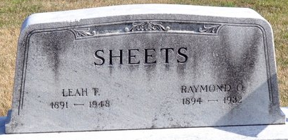
Photo by Deb Curry

Mrs Leah Ferne Sheets
in the Indiana, U.S., Death Certificates, 1899-2017
Name Mrs Leah Ferne Sheets
[Mrs Leah Ferne Walters]
Gender Female
Race White
Age 56
Marital Status Widowed
Birth Date 21 Sep 1891
Birth Place Glenmore O
Death Date 26 Aug 1948
Death Place Decatur, Adams, Indiana, USA
Death Registration Date 1948
Father Christopher Walters
Mother Clara Belle Lewis
Spouse Raymond O Sheets
Informant Carl D. Sheets; Decatur, Indiana
Burial August 29, 1948; Decatur Cemetery; Decatur, Indiana

