Judith Diane (Rawlings) Sheets
June 22, 1943 – August 31, 2024

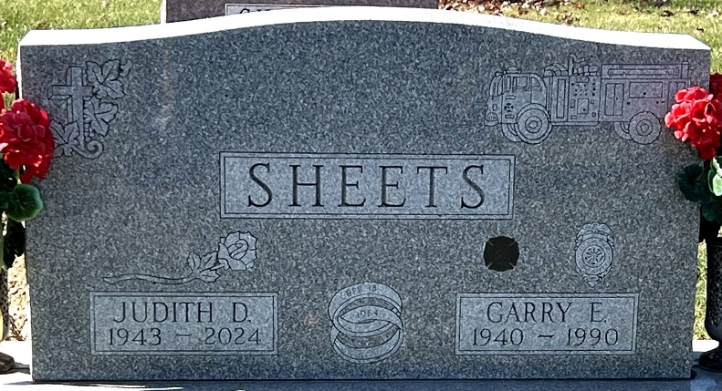
Photo by Deb Curry

Judith Diane “Judy” Sheets, 81, of Decatur, Indiana passed away Saturday, August 31, 2024, at Indiana University Healthcare - Methodist Hospital in Indianapolis, Indiana.
She was born on June 22, 1943, in Indianapolis, Indiana to the late Robert Rawlings and Doris (Godwin) Rawlings. Judy was united in marriage to Garry E. Sheets on April 18, 1964 and he preceded her in death on August 2, 1990.
She was member of First United Methodist Church in Decatur. She also was a member of the Decatur Fire Department Women’s Auxiliary, Decatur Moose Lodge 1311, American Legion Post 43 Auxiliary, VFW Post 6236 Auxiliary, and Eagles Aerie 2653 in Decatur.
Judy started working in retail and did bookkeeping, she worked at Christian Grain Inspection and then Northeast Grain Inspection for 30 years in total. In her spare time, she volunteered at Adams Memorial Hospital for many years.
Judy spent a lot of time at Big Long Lake from 1976 - 2020, enjoying many vacations with friends and family. She enjoyed playing in the VFW Post 6236 Auxiliary Annual Golf Outing, where her team always finished in last place earning them a trophy. Judy loved attending her flowers.
She is survived by her son, Scottallen E. Sheets of Decatur, Indiana; daughter, Carrie (Arpad) Horzsa of Dickson, Tennessee; grandson, Donovan Scott Horzsa of Dickson, Tennessee; granddaughter, Shelby (Alex) Knepshield of Ohio; four nieces, Sherry Hughes, Debbie (Larry) Miller, Kate (Josh) Harris, Christine Nelson; two nephews, Kendrick Rawlings, Steven Rawlings; Garry’s surviving family includes a sister-in-law, Linda Sheets of Hawaii; and two nephews, Chris (Sarah) Gay, and Jeff Gay.
Judy was preceded in death by two brothers, Don Rawlings and Richard Rawlings; sister, Barbara Joyce Friesner; and Garry’s sister, Peggy Gay.
A funeral service will be held at 12:00 p.m. Noon Saturday, September 7, 2024, at the Zwick & Jahn Funeral Home - Decatur with Life Celebrant Dave McIntire and Pastor Harold Klinker officiating. Burial will follow at Decatur Cemetery in Decatur, Indiana. Friends and family will be received from 10:00 a.m. until service time on Saturday at the funeral home.
In lieu of flowers the family prefers memorials be made out to Hoosier Burn Camp.

Zwick & Jahn Funeral Home, Adams County, Indiana
September 3, 2024

