Josiah E. Sheets
December 21, 1892 – November 13, 1971

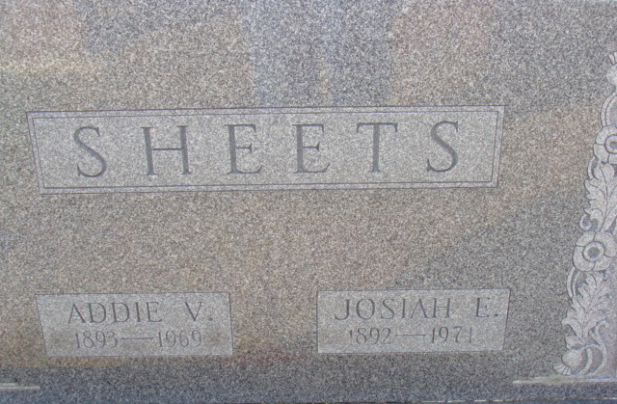
Photo by Alicia Kneuss

Jess Sheets, 78, Dies at Hospital
Josiah E. (Jess) Sheets, 78, of 957 Walnut Street, a retired farmer, died at 11 a.m. Saturday at the Adams County Memorial Hospital, where he been a patient for seven weeks. He had been in failing health for several years.
He was born in Harrison township, Van Wert County, O, Dec. 21, 1892, a son of Salomon and Mary Ellen Myers-Sheets and was married to Addie (Vola) Woods Aug. 20, 1913. His wife preceded him in death May 31, 1969.
Mr. Sheets was a member of the Union Chapel United Methodist Church.
Surviving is one son, Lloyd M. Sheets of Decatur, two daughters, Mrs. Lendall (Helen) Milheim of Tecumseh, Mich., and Mrs. Miles (Delsie) Mishiyama of Grand Rapids, Mich., 12 grandchildren and four great-grandchildren. Three sons, Lester, Lewis and Leo, and three brothers are deceased.
Funeral services will be conducted at 1 p.m. Tuesday at the Zwick Funeral Home, with Rev. Kenneth Swan officiating. Burial will be in the Decatur Cemetery. Friends may call at the funeral home until time of the services.
Preferred memorials are to the Adams County Cancer Society.

Decatur Daily Democrat, Adams County, Indiana
Monday, November 15, 1971

