Isabel B. (Sheehan) Sheets
November 9, 1918 – June 2, 1967

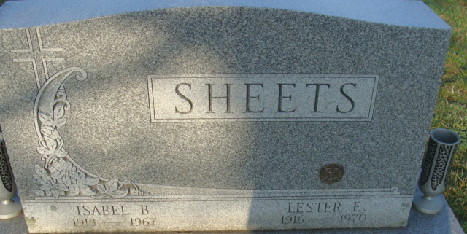
Photo by Alicia Kneuss

Indiana, U.S., Death Certificates, 1899-2017
Name Isabel B Sheets
Gender Female
Race Caucasian (White)
Age 48
Marital Status Married
Birth Date 9 Nov 1918
Birth Place Indiana
Death Date 2 Jun 1967
Death Place Decatur, Adams, Indiana, USA
Death Registration Date 1967
Father John Sheehan; Mother Bertha Poorman
Spouse Lester E Sheets, informant
Burial Decatur Cemetery 6/4/1967

