Infant son Sheets
September 21, 1907 – September 21, 1907

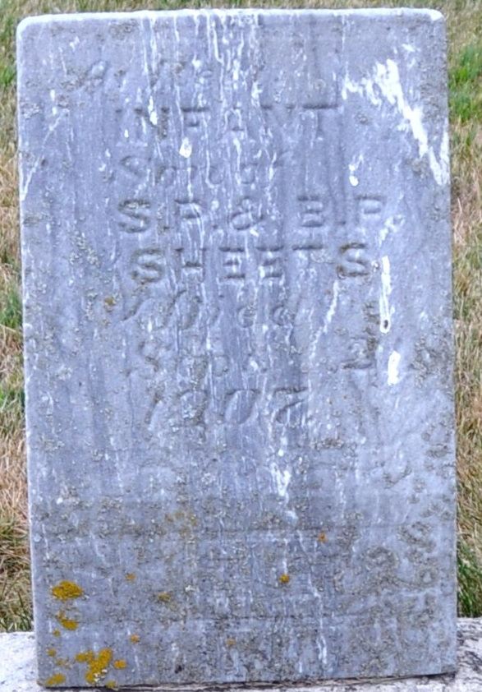
Photo by Deb Curry

Infant Sheets
in the Indiana, U.S., Death Certificates, 1899-2017
Name Infant Sheets
Gender Male
Race White
Age 0
Birth Date 21 Sep 1907
Birth Place Adams
Death Date 21 Sep 1907; stillborn
Death Place Root, Adams, Indiana, USA
Death Registration Date 1907
Father S P Sheets
Mother Bertha Rinehart
Informant S. P. Sheets; Decatur, Indiana
Burial September 21, 1907; Decatur Cemetery

